“It’s Easy Being Green” Smoothie

Ingredients:
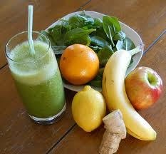
½ c water
1 c grapes
½ c fresh pineapple
1 medium banana
2 c fresh spinach (washed)
1 medium apple, quartered and seeded
4 c ice cubes

Directions:
1. Place all ingredients into the Vitamix container in the order listed and secure lid.
2. Select Variable 1
3. Turn machine on and quickly increase speed to variable 10, then to high.
4. Blend for 1 minute or until desired consistency is reached.

